Course File Top Sheet* File No: ………………………
Trimester: |  | Section:
Department |  | Course Code
Course Title:
Course Teacher
Name/Seal: Signature:

Sl. | Content (As per revised OBE Format) | Tick mark if included | Comment
1 & 2 | OBE Course Outline & Lecture Plan (Revised)  Download & prepare: http://www.pciu.net/IQAC/Services/IQACForms]
3. | Lecture materials/notes  [For Lab: Sheet/Note of Lab Theory & Procedure]
4. | Attendance sheet
5. | Assignment copies/Lab Note books
6. | - Class test/Lab Quiz □ Best □ Mediocre □ Poor  - Mid-term test: □ Best □ Mediocre □ Poor
7. | Copies of question papers/assessment tools
8. | Final Tabulation/Score Sheet
9. | Rubrics for assessment  [Download & prepare: http://www.pciu.net/IQAC/Services/IQACForms]
10. | Faculty Course Review Report (IQACOM Annex 6)  Course evaluation by course teacher with feedback from the students.  Download: http://www.pciu.net/IQAC/Services/IQACForms]
11. | Course Evaluation (by Students) Report  This report contain Feedback from the students on the course  Download: http://www.pciu.net/IQAC/CourseEvaluation/CourseReport]
12. | Peer review: Done/Not done  [Submit your course file to a reviewer (faculty member who have conducted this course previously)]
13. | Evaluation of attainment of CLOs
14. | Improvement plan for better attainment of CLOs

Approved by (Chair of the Dept.): Signature:

Received by (Corresponding Dept.): Submission Date:

[* Please keep a copy of this top sheet by faculty and concern department to find out file from archive.]

No need to print out this page (2nd Page). This page is given to discuss the importance of COURSE FILE.

Question: How to create course files for merged courses?
Answer: If the batches/sections of the same department merged for a course (CHEM 111 course for EEE-24-D-A + EEE-25-D-A), it is not necessary to prepare separate COURSE FILE. But if the sections/batches of different department (HIST 101 course for CEN-25-D-A + EEE-25-D-A) are merged for a course, it is prescribed to prepare course file separately. Course file have to be sent to corresponding department at the end of the course. According to I.E.B. accreditation manual, if any course has lab and theoretical involved, then the course file has to be created separately.

Course file mentioned in the following Manuals & Required for Accreditation of Academic Program
- Bangladesh Accreditation Council (BAC) Standards for Accreditation of Academic Program
Criterion 4-8: The PoE maintains documented course file with course plan specifying prerequisite course(s) (if any), credit value, teaching learning & assessment methods and facilities/resources that are mapped out as necessary to facilitate the attainment of course learning outcomes

- Institutional Quality Assurance Cell Operations Manual (Second Edition)
IQAC O Manual General rules1. The University should have files for each course “Course File” containing the specification, samples of previous examination sheets, and results of student evaluation of the course as well as the percentages of students dropping out, passing, and failing the course. The file should include other relevant information course as necessary.

- STRATEGIC PLAN FOR HIGHER EDUCATION IN BANGLADESH 2018-2030 (Published by UGC; ISBN: 978-984-34-4728-9, Page 81):
Detailed lesson delivery plans with expected outcomes, resource requirements, progress tracking,
course file etc. should be made for each course

- IEB Accreditation Manual (2nd Edition) Effective from 1 January 2020

The department should maintain a course file for each course offered by the department for the program in each semester of the last three academic years. If a lab is integrated with theory in any course, separate course files should be prepared for the theory and the lab parts of the course. The course files shall be made available during the on-site visit for perusal by the members of the evaluation team. The course file must contain at least the following items.
- Lecture plan detailing prerequisites, course outcomes and content, text and reference books, assessment tools for each course outcome, and grading policy
- Questions and three representative examples of answer scripts (one excellent, one average, one marginal pass) for each exam, class test and quiz (for theory courses)
- Lab sheet and three representative examples of lab reports (for lab courses)
- Assessment criteria or rubrics for assignments/projects/lab activities. Three representative examples for each assignment/project/lab activity report
- Final tabulation sheet including grade assigned to each student - Assessment of outcome achievement for each course outcome

Chapter 4 Criteria: For each course, a course file must be maintained. The course file should include the assessment of outcomes, curriculum, and examination questions and answer scripts, the results of other assessments, and a summary of performance and attainment of course outcomes with suggestions or feedback for future development.

Note from IQAC Office (PCIU) about course files

- Prepare course file as per the content given in the Course File Top Sheet (1ST Page).

- At the end of a course all course file will be submitted/sent to corresponding department. Core department will preserve the course file and will prepare a list of submitted course files.

- It is recommended to Paste/Scotch Taped the photocopy of Course File Top Sheet in the envelope/file.

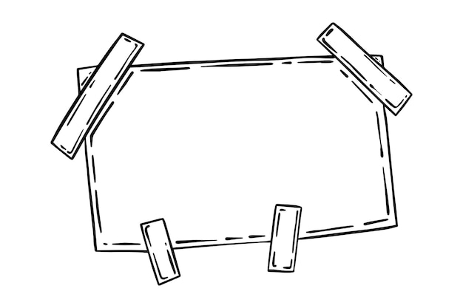

- Course file is important to prepare Annual Course Reports.
